Big Data Assignment - 2
Oracle Query – 1

Avarage salary by category
All employees are divided into 3 non-intersecting categories:
1. Heads of departments.
2. Managers (have subordinates, but are not heads of departments).
3. Ordinary workers (have no subordinates and are not heads of departments).
We consider all the departments belonging to two regions - Europe and America.
It is necessary to the average salary for each group of workers by region.
When displaying the result, the average salary is rounded to the whole by the ROUND function.
You should have the following table:
Query -
select a.Region_name Region_Name,a.DEP_MANAGER_SALARY_AVG,b.MANAGER_SALARY_AVG,c.worker_SALARY_AVG
from
(select e.region_id,e.region_name,round(avg(a.SALARY)) as DEP_MANAGER_SALARY_AVG
from hr.employees a
Join hr.departments b on a.employee_id=b.Manager_id
join hr.locations c on b.Location_id=c.Location_id
join hr.countries d on d.country_id=c.Country_id
join hr.Regions e on d.region_id=e.region_id
group by e.region_id,e.region_name) a,
(select f.Region_id,f.Region_name,round(avg(a.SALARY)) as MANAGER_SALARY_AVG from hr.employees a join hr.employees b on a.employee_id=b.Manager_id
join hr.departments c on a.department_id=c.department_id
join hr.Locations d on d.Location_id=c.Location_id
Join hr.countries e on e.country_id=d.Country_id
join hr.Regions f on f.region_id=e.region_id
where a.employee_id not in(select manager_id from hr.departments where manager_id is not null)
Group by f.Region_id,f.Region_name) b on a.region_id=b.region_id
join (select f.Region_id,f.Region_name,round(avg(a.SALARY)) as worker_SALARY_AVG from hr.employees a
join hr.departments c on a.department_id=c.department_id
join hr.Locations d on d.Location_id=c.Location_id
Join hr.countries e on e.country_id=d.Country_id
join hr.Regions f on f.region_id=e.region_id
where a.employee_id not in(select manager_id from hr.departments where manager_id is not null
union all select manager_id from hr.employees where manager_id is not null)
Group by f.Region_id,f.Region_name) c on a.region_id=c.region_id
OutPut :
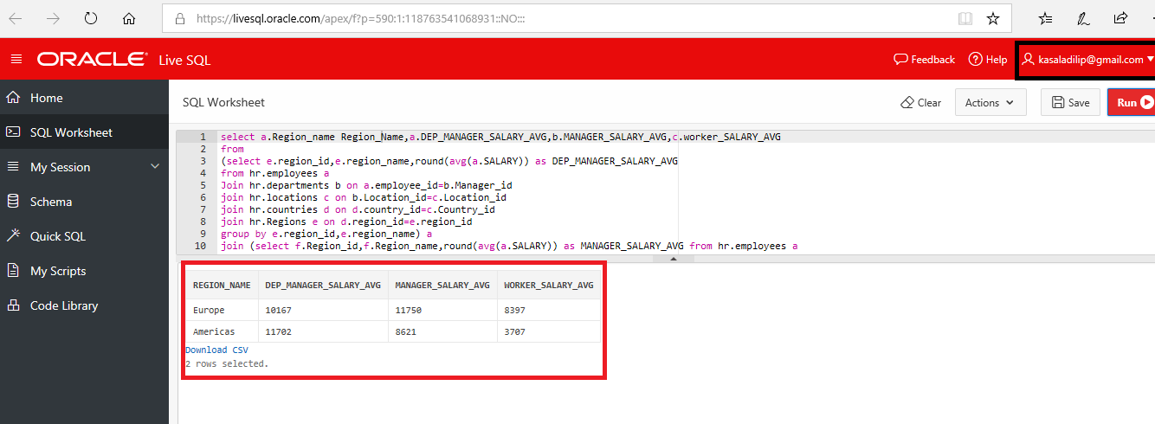

Oracle Query – 2

Defference between salary of managers and their employees
The controlling authorities requested information on how the salaries of the management of the company differ from the average salary of their immediate subordinates. In this regard, it is necessary to prepare a list of managers containing the following fields: position, name, surname, manager's salary, number of employees subordinate, average salary of subordinates, deviation of the head's salary from the average salary of subordinates (percent, rounded to two decimal places).

Query –
SELECT M.Job_title,e.employee_id,e.first_name, e.last_name, e.salary,A.count as Counts, round(A.avg,2) as Avg_sal, round(((e.salary/A.avg)*100),2) as Deviation
from hr.employees e,
(select e.manager_ID,count (e.employee_id) count, sum(e.salary), (sum(e.salary)/count (e.employee_id)) avg FROM
hr.employees e group by e.manager_ID order by 1) A
(select distinct e.job_id,j.job_title from hr.employees e,hr.jobs j where e.job_id=j.job_id) M
where e.employee_id= A.Manager_id and e.job_id=M.Job_Id order by e.employee_id;

